A Mill End Christmas 2024
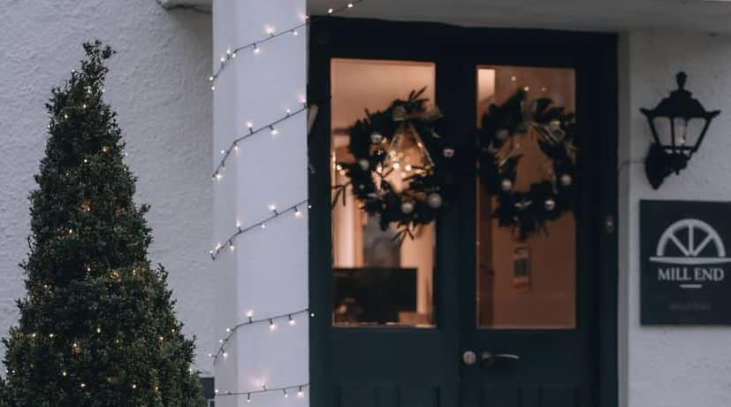

Celebrate Christmas in Quaint Luxury
At the Mill End Hotel 2024
See below our full prospect itinerary from the 24th to the 27th of December 2024! Rooms, teas and restaurant visits can be booked via our website or by call on 01647 432 282

~Tuesday 24th of December
It’s time to settle in and make yourself at home with some mulled wine, coffee or pot of real tea and home-made mince pies. This can of course be upgraded, as long as you call ahead of time, to our full winter afternoon tea spread. Our lunch menus and cream tea can be ordered on the day.
Hopefully it will be nice enough for a walk during the afternoon, in which case do stop by reception for some route suggestions. Whether you walk or drive, the village of Chagford is a nice choice for a bit of very-last-minute Christmas shopping (7 minutes by car, or 30 minutes on foot). Alternatively, relax and enjoy our comfy lounges, browse our bookshelves, or indulge in a board game or two. In the evening, we will start with delightful canapés and a glass of bubbly, followed by an amuse bouche, starters, main course with wine pairings, then dessert.
- Tea and homemade mince pies on arrival
- Dining times from 18.30pm. Please reserve your preferred time pre-arrival
- At 7pm, bubbles & Canapés will be served in the restaurant upon your arrival. We will then serve our six course dinner, with matched wines.

~
Wednesday 25th of December
A warm and heartfelt Merry Christmas from the whole team here at Mill End. If you can drag yourselves away from present-opening, a delectable breakfast selection awaits you in the restaurant. We look forward to welcoming you in the restaurant, along with friends old and new, for a hearty, traditional Christmas Lunch along with some light entertainment. Naturally, we’ll have turkey and “all the trimmings”, but there will also be some other tempting options. In the evening, our chefs will prepare a buffet that you can peruse if you aren’t too full.
- Bucks Fizz Breakfast is served from 7:45am until 9:15am
- Christmas Lunch is served from 12pm until 2pm, please reserve a time with us before arrival
- Seasonal buffet Dining times from 7pm. Please reserve your preferred time pre-arrival

~
Thursday 26th of December
Start the day with our “Full English” (or one of our other tempting breakfast choices). Clear the cobwebs with a walk along the river to Fingle Bridge (great for canine companions!), relax in the comfort of the hotel or take part in our festive quiz! However you choose to spend your day, we look forward to serving you a delicious three-course farewell supper in the evening.
- Breakfast is served from 8.30am to 10.30am
- Farewell supper is served from 6.30pm onwards

~
Friday 27th of December
If you are leaving us today, we’ll be sorry to see you go. Whilst check-out time is 11:00am, you are very welcome to leave your car in our car park if you want to take a final walk before you leave. We hope to see you again next year!
- Breakfast is served from 7:45am until 9.15am
- For those guests staying on, dinner is available in the restaurant from 6.30pm onwards, please reserve your preferred dining time pre-arrival.

